**Git commands and Q&A**

**Git Commands**

1. What is Git?

* Git is source control management tool (Version control system)
* Git is used to track history of code changes
* Git tracks the changes you make to files, so you have a record of what has been done, and you can revert to specific versions should you ever need to.

1. Benefits of using git

* It maintains history of code changes.
* We can go to any date in past and check the code at that point
* Used to collaborate efficiently in team
* Allows multiple developers to work on feature in parallel (independently)
* Lost files can be easily recovered using history available

1. Types of Version control System

* Local VCS
* Centralized VCS
* Distributed VSC

1. What are GIT Services?

* Git: Software/Command line Tool
* Github: Git website (microsoft)
* Gitlab: Git website

1. What is git repository?

* Repository is directory/folder which stores all project files online
* It also has all past versions of all files

1. What is git clone?

* The Git clone command is used to make copy of repository from existing url

1. What is git pull?

* Git pull is used to fetch the changes from online repository

1. What is Branch?

* Branch is separate copy created by each developer for their independent work on new feature

1. How the branch is merged to main branch?

* Developers creates pull request from his feature branch to main branch
* Then other developers review the pull request and merge it into main branch

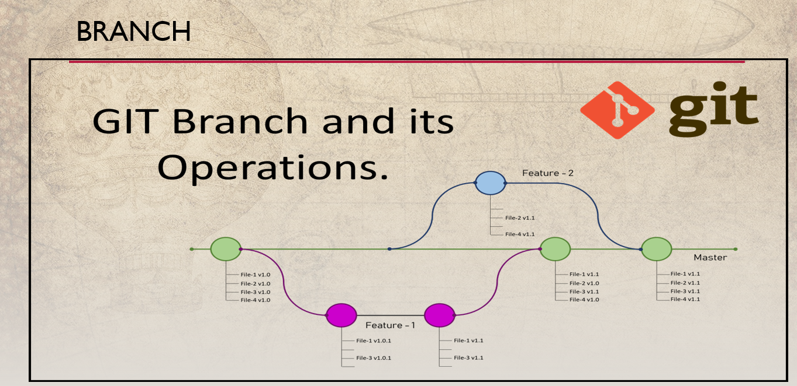

**Git Commands:**

1. Clone existing Repository from Github

* *git clone <repo_url> (*[*https://github.com/PriyankaMetkar/GitTest.git*](https://github.com/PriyankaMetkar/GitTest.git)*)*

1. Check status of files changed/modified

* *git status*

1. Add file to staging area

* *git add <file_name>*

1. Commit the staged changes using message

* *git commit -m <"commit message">*

1. Upload/push the latest commit changes to the central or online repository

* *git push*

1. To check what is changed in file

* *git diff <filename>*

1. To check history of commits

* *git log --graph*

1. Remove File

* *git rm <filename>*

1. Pull the changes from online repo

* *git pull*

1. List all existing branches (show all branch names)

* *git branch -a*

1. Change git branch

* *git checkout <new_branch_name>*

**Git Workflow (How to push changes of online repo):**

**Step 1:** git add (add changes to stagging area)

**Step 2:** git commit (tags current changes using message)

**Step 3:** git push (upload/push the latest commit changes to central repo/ online repo)